## Quick Reference Guide

## Attach a CR to a release

Many teams choose to organize their CRs by attaching them to releases. This helps with scheduling and project management. This guide will show you how to attach a CR to a release from the CR page.

1. From the CR page, click the **Click Here for the Update Actions** menu to expand it.
2. Click the **Update the PMO Fields** button.

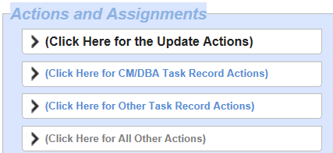

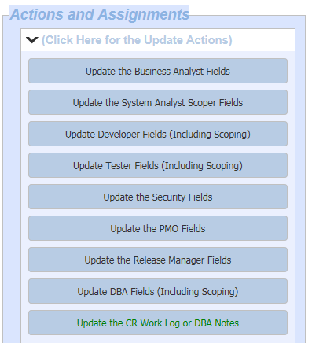

1. Select an existing release from the **Attached to this Release** drop down menu. Click the **OK** button.

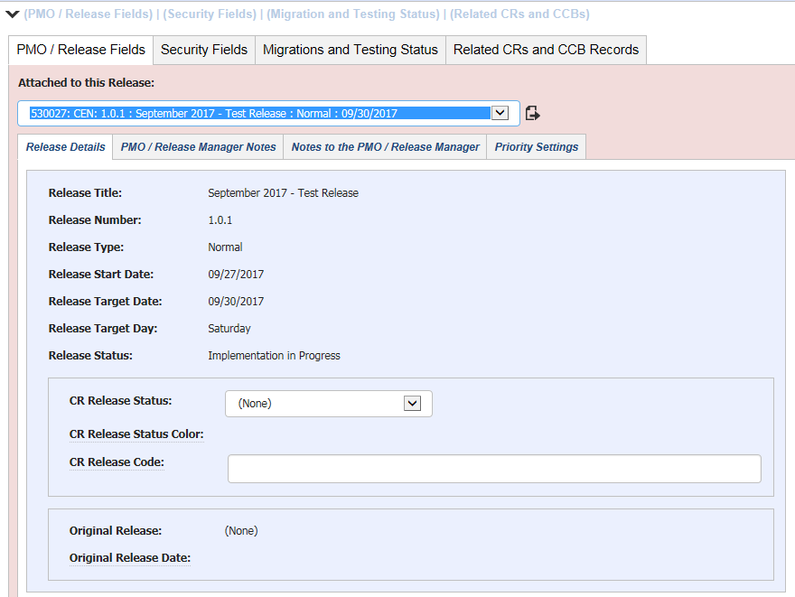



1. The **PMO/Release Fields** tab displays and the target release date displays next to the CR #.

